CEN 4010 Principles of Software Engineering, Fall 2021

Covid Connections

*By Team Onux*

Project Team 8

**Team**

Van Campbell – Scrum Master, Technical Writer - vcampbell2019@fau.edu

Samuel Adkins – Product Owner, Front-end Lead - [adkinss2020@fau.edu](mailto:adkinss2020@fau.edu)

Achelin Felix - Front-end Developer - [felixa2017@fau.edu](mailto:felixa2017@fau.edu)

Gustavo Rodriguez – Back-end Lead - [Grodriguez2017@fau.edu](mailto:Grodriguez2017@fau.edu)

Samuel Yambo -Front/Back-end Developer- [syambo2020@fau.edu](mailto:syambo2020@fau.edu)

Frecks Bertrand II – Front-end Developer - [fbertrandii2017@fau.edu](mailto:fbertrandii2017@fau.edu)

Michael Merlo -Technical Writer- [mmerlo2015@fau.edu](mailto:mmerlo2015@fau.edu)

Milestone 4 Beta Launch & Reviews

11/03/21

Revision History

#1 – 9/28/21

#2 – 10/11/21

#3 - 11/03/21

#4 - 11/12/21

Table of Contents

Product Summary 2

1) Name of Product 2

2) List of Committed Functions 2

3) Unique Features 3

4) URL 3

Usability Test Plan 3

Scope and Objectives: 3

Test Plan: 3

QA Test Plan 5

Code Review 5

Best Practices for Security 7

Non-Functional Requirements 7

Compatibility Requirements: (Done) 7

Expected Load: (Done) 8

Storage Requirements: (Done) 8

Availability Requirements: (Done) 8

Performance Requirements: (On Track) 8

Security Requirements: (On Track) 9

Status Demo 9

# Product Summary

#### Name of Product

Covid Connections

#### List of Committed Functions

1. Creating, posting, and replying on **Forums**
2. **Secure Account Creation** and **Sign In/Login**
3. **Covid Resources**
4. **Game**s
5. Posting and sharing of **Images** (may delete)
6. **Homepage** displaying the weather in your area, directory to all other functions, and personal account page (may delete)

#### Unique Features

Covid Connections is a new and exciting social media platform that allows residents of Florida to connect throughout the Covid-19 pandemic. The site features forums, games, and resources about Covid-19. Covid Connections also is the first of its kind to completely respect the member’s privacy, and not sell any data to third parties.

#### URL

https://lamp.cse.fau.edu/~cen4010_fa21_g08/home/index.php

# Usability Test Plan

### Scope and Objectives:

For this usability test, the reply/comment function will be tested. This has the added effect of ensuring that users can easily and successfully log in to the site, as the forums are restricted to registered users. The expectation is that feedback will be received from the user based on how easy or difficult it is to navigate the site, access posts, and submit a reply/comment. Any bugs, unexpected outcomes, or challenges will be documented at the end of this test. Feedback will be delivered to the development teams for improvement prior to the final launch of the product.

### Test Plan:

**Tester:** Anyone who has not worked on the backend of the product.

**Equipment:** The only tool required will be a computer with access to the internet.

**Schedule:** Testing can be done at the user’s convenience. Dedicate 5-10 minutes at a time of your choosing to access the site and perform the tests outline below.

**Starting Point:** <https://lamp.cse.fau.edu/~cen4010_fa21_g08/home/index.php>

**Credentials:** Username/email: [test@test.com](mailto:test@test.com)

Password: 12345

**Test Steps:**

1. Navigate to the product homepage.
2. Click the login button at the top right of the screen.
3. Log in using the credentials provided above.
4. Upon successfully logging in, user will be redirected to the homepage. At this point, the only functioning links are “Forum” and “Logout”. The user should attempt to access the forum from both the navigation bar at the top of the page and the forum icon located near the middle of the page.
5. The forum homepage will display all topics and a preview of posts within those topics. Please ensure that the footer identifies you as “testUser” and that the data on the forum homepage is useful and accurate.
6. Select any forum from this page.
7. The next page will display all posts within the forum. Please ensure that the data on this page is useful and accurate.
8. Select any post from this page.
9. The original post will be displayed first and then all replies will be displayed in the order in which they were posted. Please ensure that the data on this page is useful and accurate.
10. The user then has 2 methods for posting a reply. Please first test clicking the “comment” button located on the original post. A text box will appear. Try entering a comment and submitting it. Note – if the content of the comment is empty or if it is only white space, the server will not add the comment to the database.
11. Ensure that your submitted comment is displayed at the bottom of the thread.
12. Now try using the “reply” button located on any of the other posts. A text box will appear. Try entering a reply and submitting it. Note – if the content of the reply is empty or if it is only white space, the server will not add the comment to the database.
13. Ensure that your submitted reply is displayed at the bottom of the thread.

**Questionnaire:** Please circle one of the answers below for each question.

|  |  |  |  |  |  |
| --- | --- | --- | --- | --- | --- |
| **Question** | **Strongly Disagree** | **Disagree** | **Neither Agree Nor Disagree** | **Agree** | **Strongly Agree** |
| 1. The forums were easy to navigate | 1 | 2 | 3 | 4 | 5 |
| 2. Adding comments and replies is something I could do without a guide in the future. | 1 | 2 | 3 | 4 | 5 |
| 3. The forum was visually appealing | 1 | 2 | 3 | 4 | 5 |

# QA Test Plan

# Code Review

Coding Style:

For this code review, we are reviewing the Front page and Forum page. Here Samuel Yambo is reviewing the work done by Samuel Adkins, to ensure correctness and style.

Here are some snapshots of the code that was commented on, and needed to be reworked

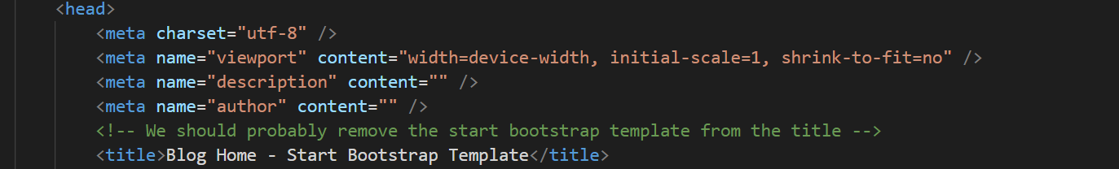

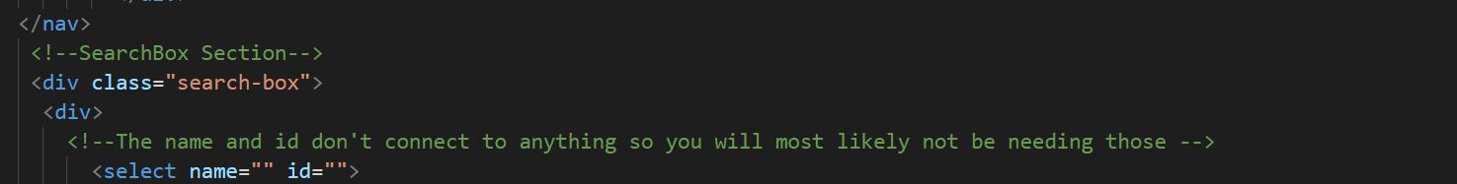

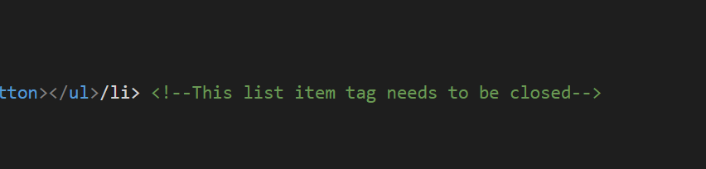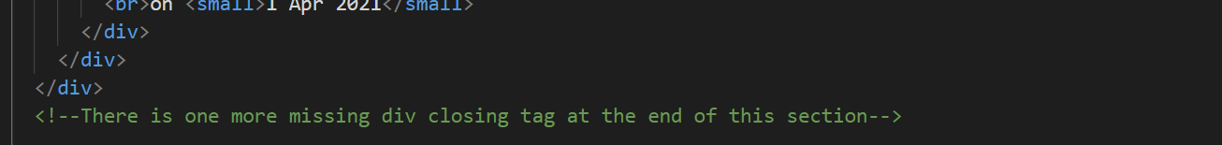

# Best Practices for Security

The list of assets that will be protected by the system are the user password and the database layers.

The user password will be encrypted using RIPEMD hashing. RIPEMD hashing is a hash function that convert normal data to irregular values which will allow the password to be secured and encrypted. Before encrypting the password there will be a two salt phrases to further protect the password.

The database layer is also encrypted. The strings inputs will be sanitized in queries which will prevent SQL injection attacks. For input validation, the user password and the username will be checked against the database to see if it’s input correctly. Also, before any post or images are modified, the system will verify that the original user is still logged in. The search inputs will be sanitized through queries to see if the inputs were true.

# Non-Functional Requirements

### Compatibility Requirements: (Done)

The website is compatible with all browsers.

* Browser (Done):
  + The website is compatible with Chrome, Safari, and Firefox. All the requirements are met
* Computer and OS (Done):
  + There are no particular OS that being used.

### Expected Load: (Done)

The website will be run through the lamp server. There is no plan to add anything that would overload our current system.

### Storage Requirements: (Done)

System will be stored on LAMP server. Backup options are not yet determined but may include cloud storage for image and database files.

### Availability Requirements: (Done)

The website is currently being run on the lamp server if the lamp server is not available. The site will be unresponsive.

### Performance Requirements: (On Track)

* Responsiveness (Done):
  + The website is implemented using bootstrap. The overall theme is a combination of a variety of different styles, all centered around connection.
* Test Requirement (On track):
  + The test requirement is being implemented currently. As a team, we will be testing how the search correspond to certain inputs.
* Reliability (Done):
  + The website is currently being run on the lamp server, If the lamp server is not available, the site will be unresponsive.
* Bug Count (On track):
  + So far there has not been any bugs reported. We run daily updates to make sure that there are no bugs being implemented in the code, as well as peer reviews.

### Security Requirements: (On Track)

* Login/Password (Done):
  + The login was recently implemented. It is run through the database. The password is being encrypted on our database.
* Test Requirement (On track):
  + The test requirement is being implemented currently. As a team, we will be testing how the security correspond to certain inputs. It is being tested on to see how it would operate with a user that visit the website.
* Reliability (Done):
  + The website is currently being run on the lamp server, If the lamp server is not available, the site will be unresponsive.
* Bug Count (On track):
  + So far there has not been any bugs reported. We run daily updates to make sure that there’s no bugs being implemented in the code, as well as peer reviews.

# Status Demo

YouTube Link: